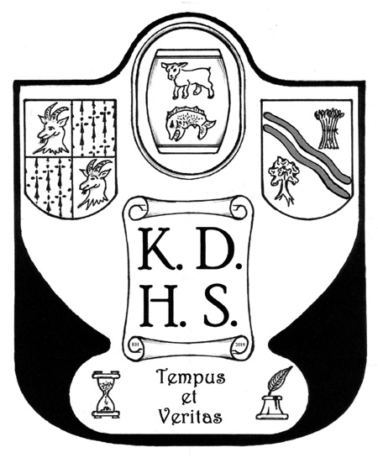
Kidlington & District Historical Society Newsletter
2nd Quarter 2023
Chairman’s Note
I should like to begin this Newsletter by thanking Peter Dewey who has offered to write up the reports of our meetings. I am very grateful to him for coming forward to do this.
Annual Visit to Lacock Abbey, Saturday 12th August
There are still plenty of places on the coach for the visit to this fascinating house and pretty village, so do please take up this opportunity to visit them. The coach leaves Kidlington Baptist Church at 10am. The cost to NT members is £16.00 (coach) and to non-NT members £33.00 (coach and entrance). If you know of non-Society members who would like to come the costs to them are £18 and £35 respectively. Please contact Olive Williams on 01865 372795 to book a place.
Annual Buffet
Dining costs have risen so much that we decided to hold a Buffet, rather than an Annual Dinner. This took place on Friday 19th May at the Willow Tree Café and was judged to be a great success. We were very pleased to welcome Norma as a guest.
April Meeting
80 years of flying operations at Brize Norton by Trevor Jackson
The construction of Brize Norton (Brize) began in 1935 as part of a programme to bring the RAF up to strength. It opened in 1937 with a 1,000 yard grass runway.
It began life as a training airfield, with open cockpit biplanes. There were a number of satellite airfields nearby to enable practice landings and take-offs.
In August 1940 the Luftwaffe bombed the airfield, destroying 35 Oxford trainers and 11 Hurricanes. After that the illusion of an airfield at Chimney was created by lighting a flare path there each night – the air-raid shelter for the aircraftmen lighting the flare path remains.
Two concrete runways were built during the war.
In 1942 the training squadrons were replaced by glider squadrons and in 1944 No. 296 and 297 squadrons took part in D-Day, their gliders’ troops capturing vital bridges over the Orne river.
As the Cold War intensified, Brize Norton, along with Fairford, Upper Heyford and Greenham Common became bases for the bombers of the US Strategic Air Command. The SAC invested heavily in the airfield, including extending the runways to 9,000 ft.
The USAF handed the base back to the RAF in 1965, and it became a major strategic transport airfield – a role it has had ever since. Initially VC-10 jets and Short Belfast heavy lift planes were deployed there. From 1984 ex-civilian VC-10s, converted to air-refuelling tankers were stationed at Brize.
After the Falklands war the RAF found it needed additional long-distance capacity and in 1984 No. 216 Squadron was reformed with nine ex-civilian Lockheed Tri-stars. In 2001 the base received the first of eight C17 Globemaster transport aircraft.
The base has been the target of anti-war protests from time-to-time, and during the 2003 Iraq War four protesters managed to reach the main runway in an effort to prevent planes taking off.
In 2011 all the RAF’s transport planes and air-refuelling planes were concentrated at Brize. It became the RAF’s biggest base and major redevelopment took place to accommodate the additional planes, including C-130 Hercules and Airbus A400M and A330 Voyagers. In 2013 the last two VC-10s left.
During the evacuation of personnel from Afghanistan in 2021, a C17 carried 439 passengers in one flight.
Planes from the base fly equipment to Poland for transfer to Ukraine, and it is currently involved in the evacuation of UK citizens from Sudan to Cyprus.
May Meeting
Our scheduled speaker for May had to drop out and her place was taken at short notice by Richard Dudding, who gave us a most interesting talk on Radley Manor and Village.
The Manor was held by Abingdon Abbey as part of their Manor of Barton from 1050 to the dissolution of the monasteries in 1538, when it passed to the Crown. It had become a manor in its own right and in 1560 was sold to the Stonhouse family, upwardly mobile Londoners. They held it until 1795, when it passed to relatives, the Bowyers. Their decline saw the Hall and grounds being bought by the founders of Radley College in 1847.
The parish’s area is about 3,000 acres and its boundaries are similar to those of the Manor. In 1260 the Abbey created a deer park – important at the time for food (deer and other game), hunting and timber. They were usually round to economise on fencing, with the fence and a ditch arranged so that deer could jump in, but not out. Radley Large Wood is the remains of the deer park.
The Stonhouse family paid £900 for very specific powers as Lords of the Manor. The family survived the Civil War, despite being Royalists, and Sir John Stonhouse became a privy councillor and built the Hall – now part of Radley College – in the 1720s. Capability Brown did some work on the grounds.
The last generation of Stonhouses were three childless brothers and the Manor passed to the Bowyers, relations by marriage. Three generations of Bowyers (all Sir George) ruined the estate’s finances. The last converted to Catholicism, but the large sums he gave to charities were all with borrowed money and on his death creditors demanded a sale. The Hall was bought by the founders of Radley College. Wick Farm and Hall, also part of the Manor, was sold to a Mrs Dockar-Drysdale. By the 19th Century the role of lord of the manor had changed to become that of squire, exercising influence through land-holding and wealth rather than through legal powers, and the Dockar-Drysdales took this role very seriously.
With the purchase of the Hall, Radley College acquired the ‘advowson’, the right to appoint the vicar of the parish church, and used it to appoint a vicar whose ecclesiastical views they approved of. This despite the opposition of Sam Wilberforce, Bishop of Oxford (better known as Darwin’s opponent).
June Meeting
At our AGM on 27th June the formal business was swiftly dealt with so that we could enjoy Bill King’s talk on ‘The First Two Years of World War One’. He covered the period between the outbreak of war in August 1914 and November 1916, the end of the Battle of the Somme, at which Britain’s New Armies received their baptism of fire.
Bill opened with the sobering statistic that 7 million men – out of a total population of 35 million - served in the British armed forces in WW1. The war began as a series of treaty obligations pulled in one nation after another: Austria’s ultimatum to Serbia drew in Russia, which drew in Austria’s ally Germany. The Germans were determined to knock out Russia’s ally France quickly, but their invasion route through neutral Belgium drew in Britain.
Compared with the conscript continental armies, Britain’s volunteer army was only 300,000 strong. However, there was huge enthusiasm to join up, as the war was expected to ‘be over by Christmas’. One feature was groups of men joining together in ‘Pals’ Battalions’.
The Germans’ attempt to knock out France quickly failed and by October 1914 there were trenches from the Channel coast near Ostend to the Swiss frontier, setting the pattern for war on the Western Front until 1918. An attempt to bypass this was the Gallipoli expedition in 1915 – an attempt to knock out Germany’s ally Turkey and capture Constantinople. It was a disastrous failure.
By 1915 industrialised warfare was setting in. There was a social revolution as huge numbers of women entered industries such as munitions in place of men at the front. The chemicals they worked with turned their skin yellow and gave them the nickname ‘canaries’.
The Germans used poison gas for the first time. The British naval blockade on Germany and her allies started a slow strangulation which intensified as the war continued. The Germans responded with submarine warfare, but the sinking of the Lusitania, with the loss of 1,200 lives, 128 of them US citizens, contributed to America’s entry into the war in 1917.
The Battle of the Somme started on 1st July 1916 and was when Kitchener’s New Armies went into action on a large scale for the first time. The opening bombardment had failed to cut the Germans’ barbed wire entanglements or demolish the dugouts where they were sheltering. British troops marched into a hail of fire and suffered 40,000 casualties in the first 20 minutes of the battle. When ‘Pals’ Battalions’ suffered heavy losses the casualties might be concentrated in a single street. The battle dragged on until November, but the gain of only seven miles had come at an appalling cost, and the battle marked the point at which it was clear that the war would be prolonged and bloody.

